**Node code to IIS**

Through Proxy:

Create VM

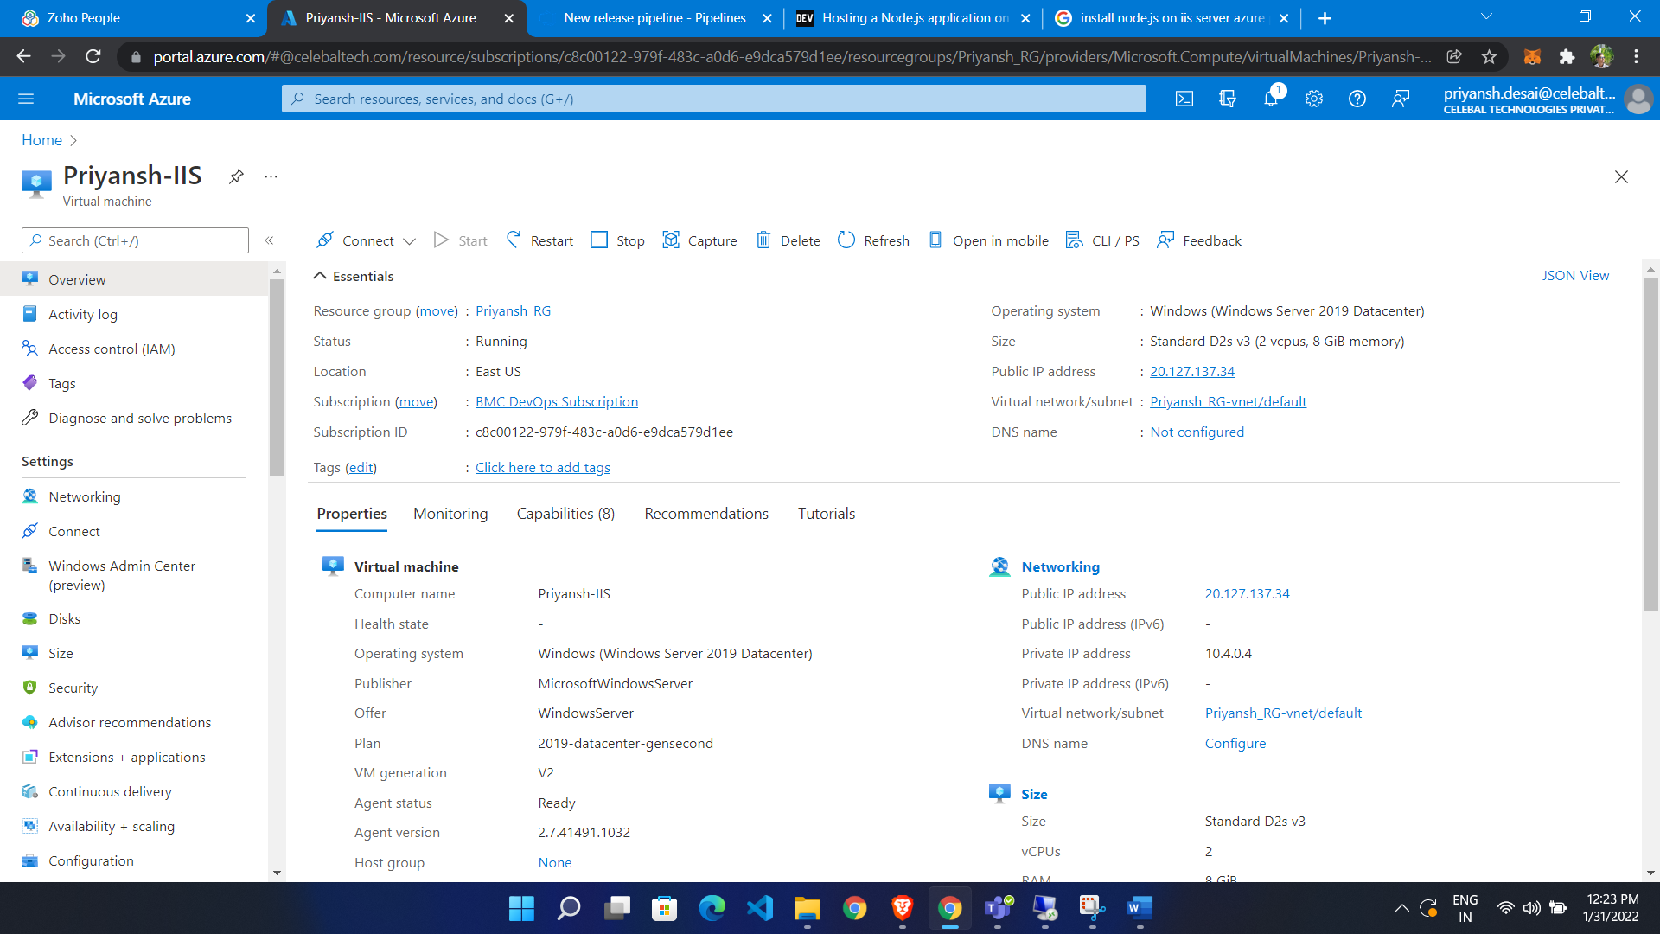

Go to azure DevOps portal:

Import your code

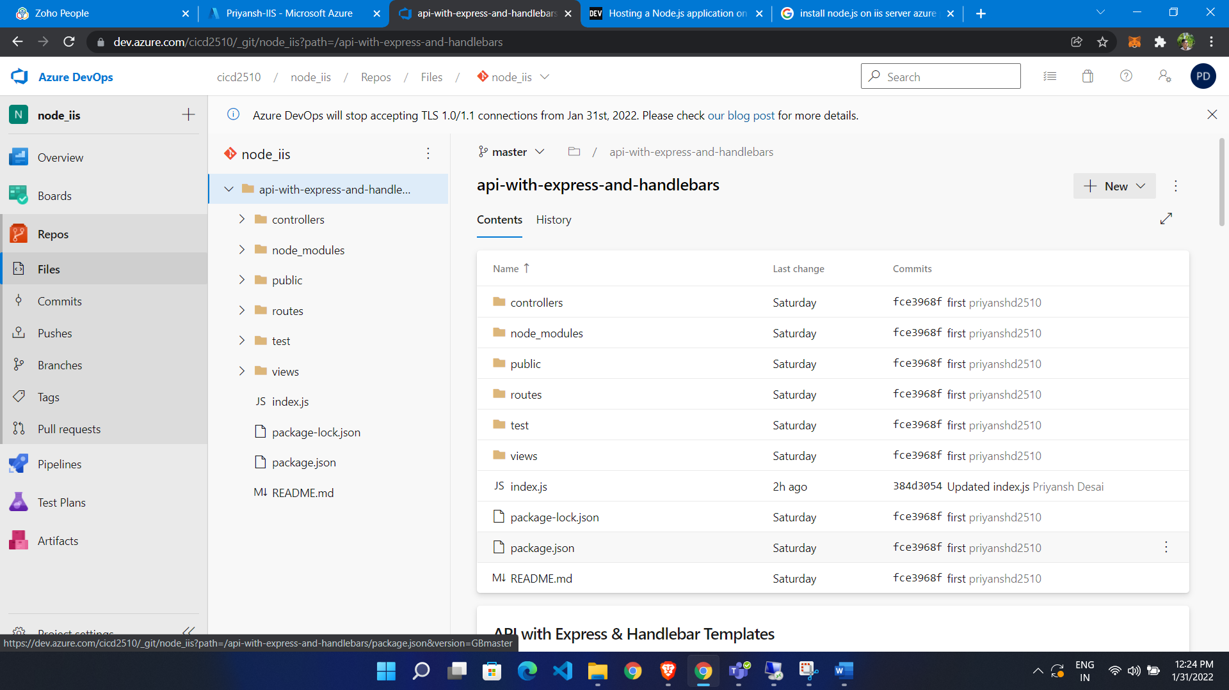

**Now build pipeline**

* Go to pipeline
* Click build
* Click create
* Select empty job
* Add job

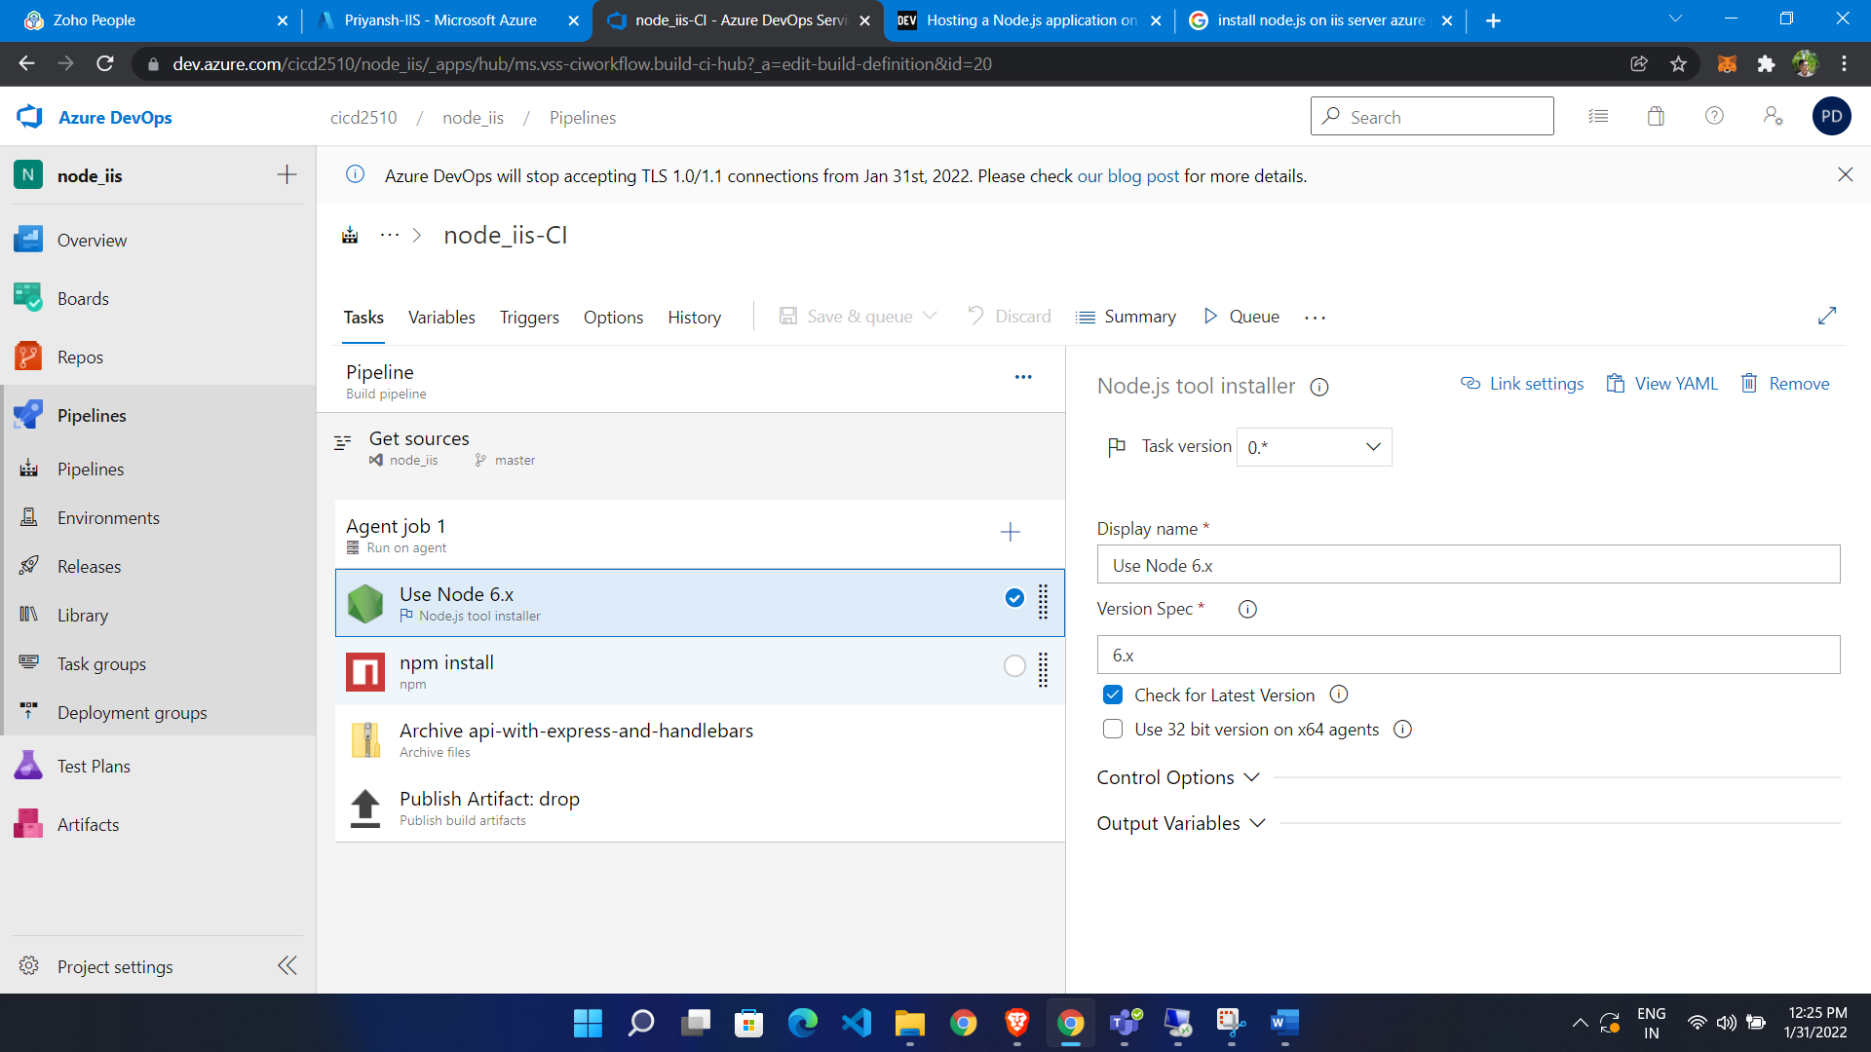

Now run build pipeline

**Make Deployment group:**

* Click deployment group
* Click create
* Copy script and run it on VM

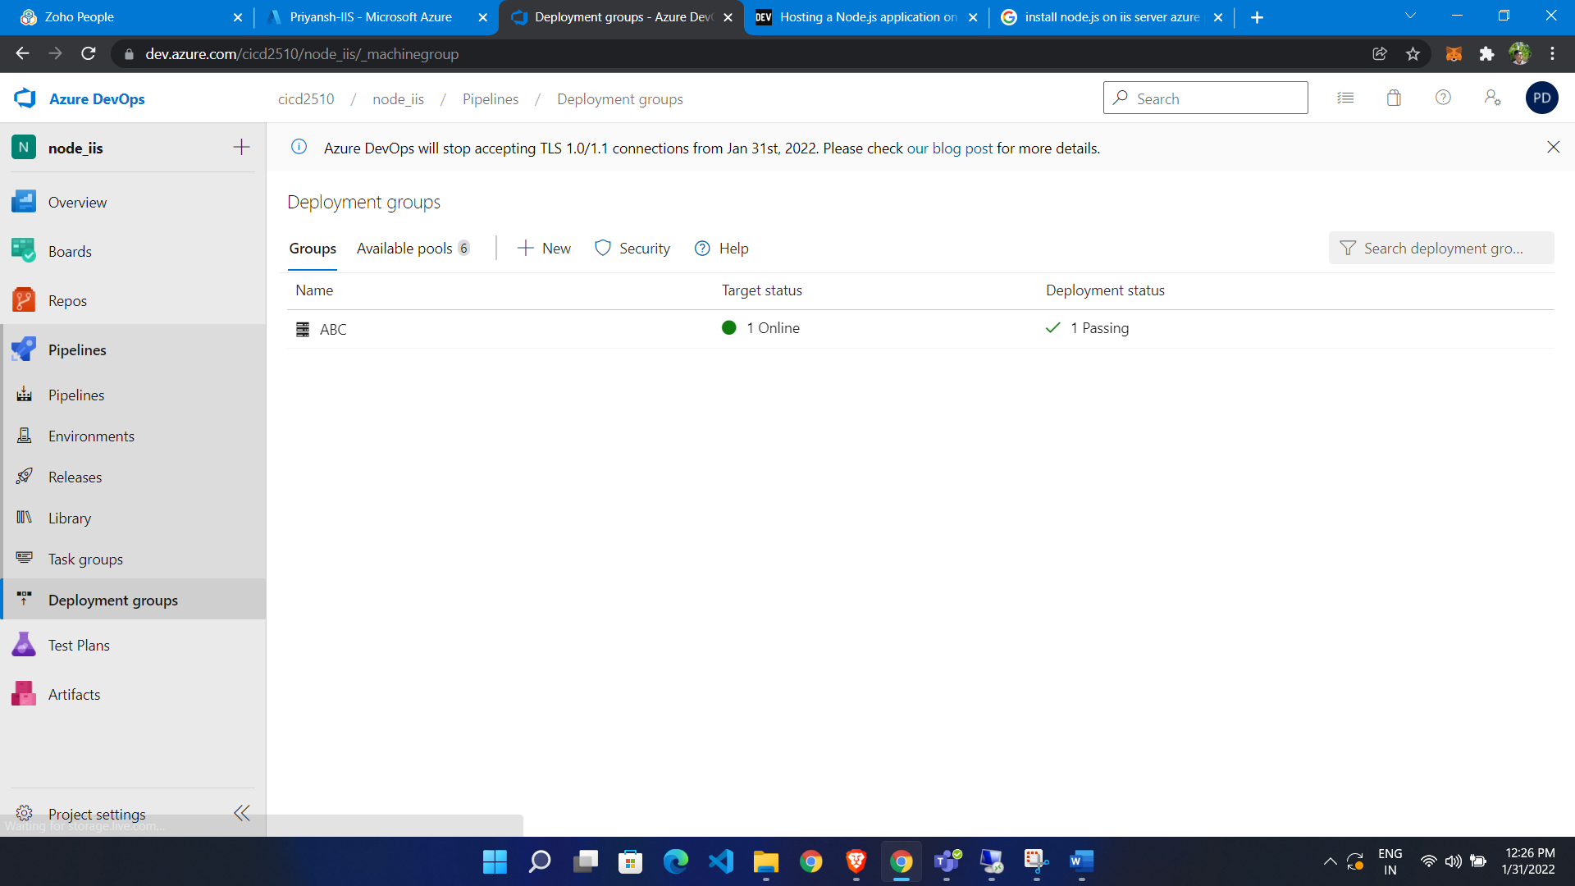

**Release Pipeline**

* Select Artifacts
* Select IIS deployment jobs
* Release pipeline

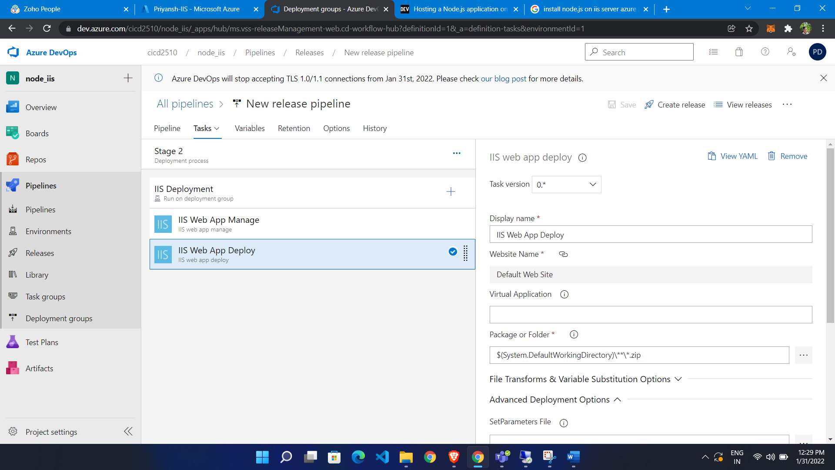

Go to virtual machine and install node js and run server

Via npm start

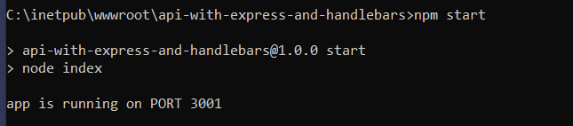

Add URL rewrite rule:

<https://www.iis.net/downloads/microsoft/url-rewrite>

Click “Install this extension”. It will open the “Web Platform Installer” start initiating.

Press “Install” and “I Accept”

After installing, you will see the “URL Rewrite” module in the IIS section.

Open IIS server setting

Click on URL rewrite

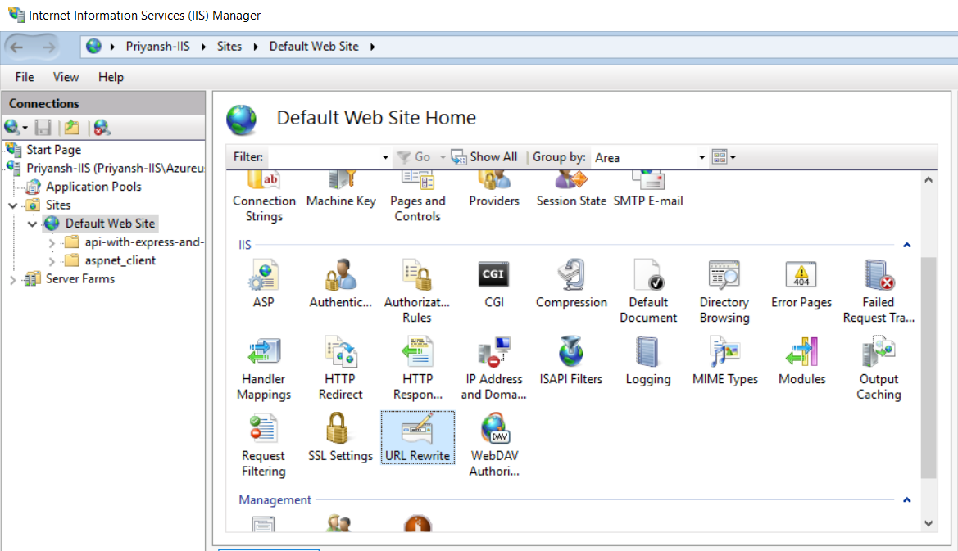

Click Add rule:

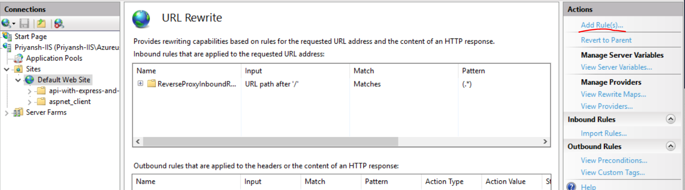

Select reserve proxy

Enter port

Add the value as “localhost:<port number>”. In my scenario, it will be localhost:3000.

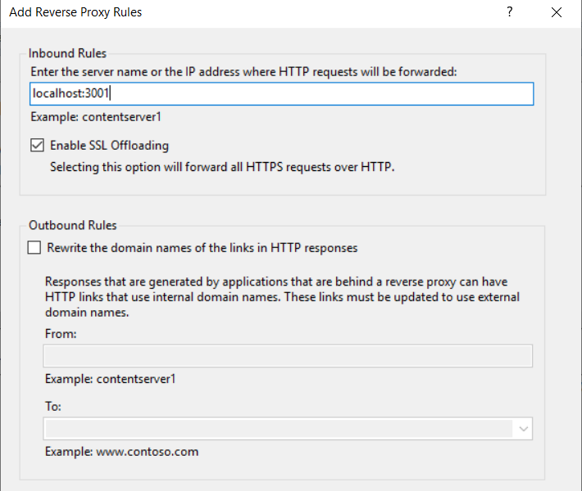

It will re direct port 3001 to port 80

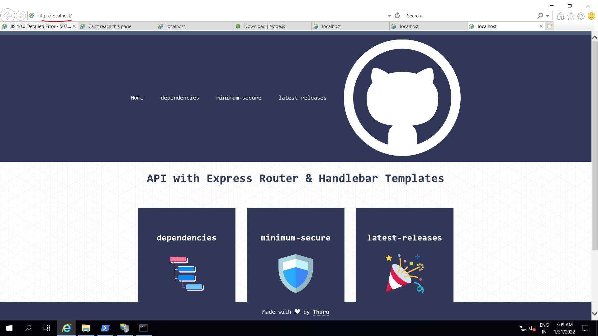

We also able access it via public IP of our VM